**Documentation of Map Reduce**

-Prepared by Vignesh.R

MapReduce is a processing technique and a program model for distributed computing based on java. The MapReduce algorithm contains two important tasks, namely Map and Reduce. Map takes a set of data and converts it into another set of data, where individual elements are broken down into tuples (key/value pairs). Secondly, reduce task, which takes the output from a map as an input and combines those data tuples into a smaller set of tuples. As the sequence of the name MapReduce implies, the reduce task is always performed after the map job.

**Creating WordCount.jar and exporting it:-**

**Step 1:**

Open Eclipse and Click on File > New > Java Project.

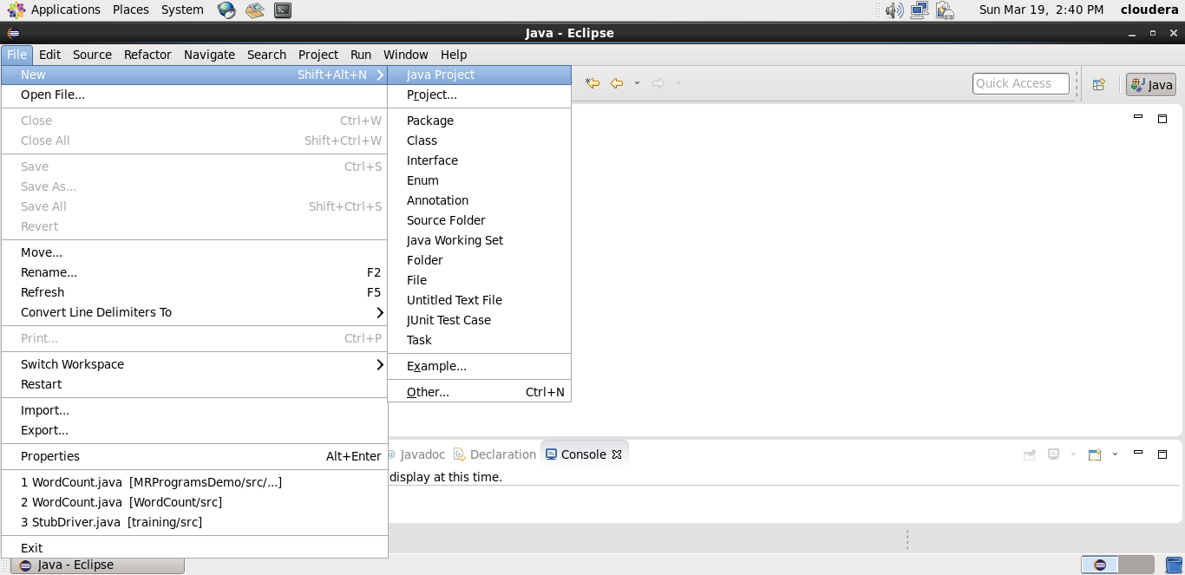

**Step 2 :**

Give the name ‘WordCount’ as your project name and click ‘Finish’.

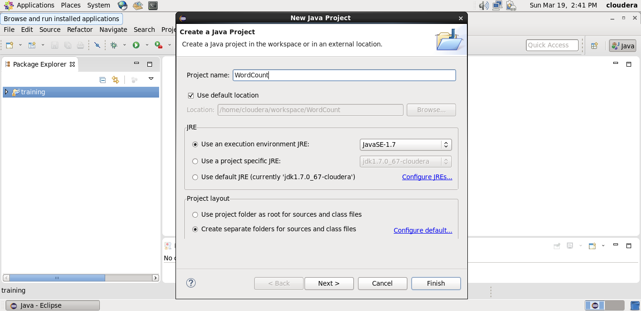

**Step 3:**

Right click on WordCount project and select ‘Properties’. Click ‘Java Build Path’ and switch to Libraries tab and click on ‘Add external JARs’.

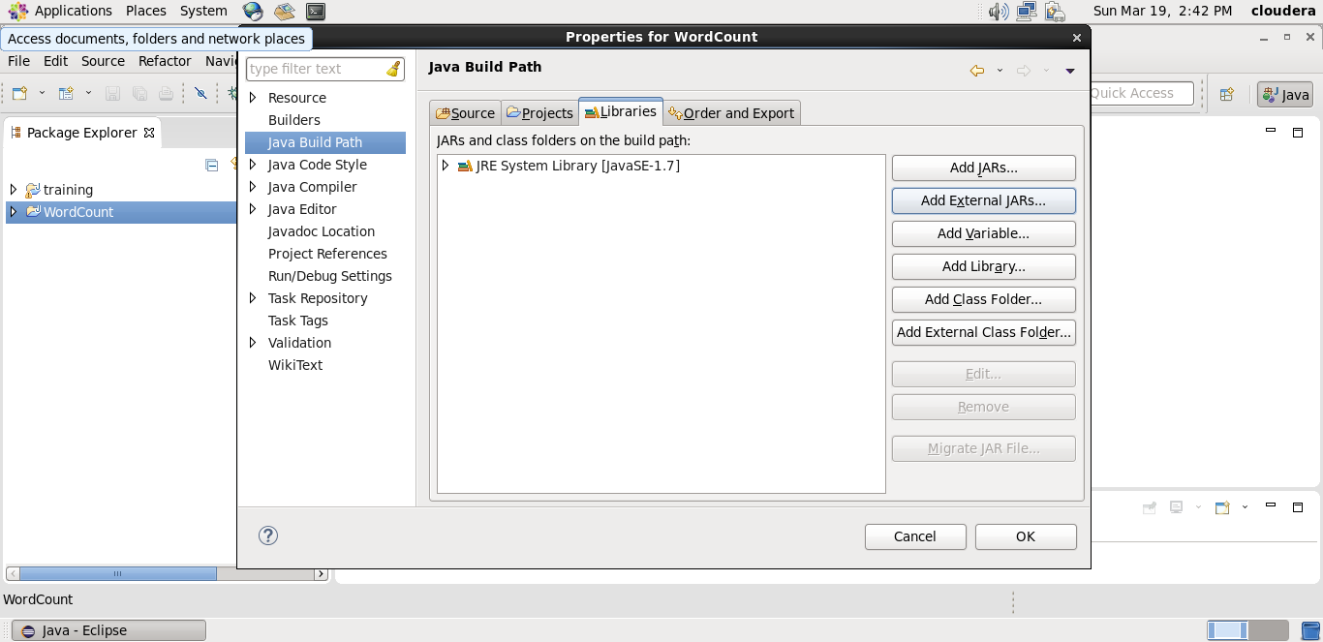

**Step 4:**

Select all the JAR files in usr >> lib >> hadoop directory to add them.

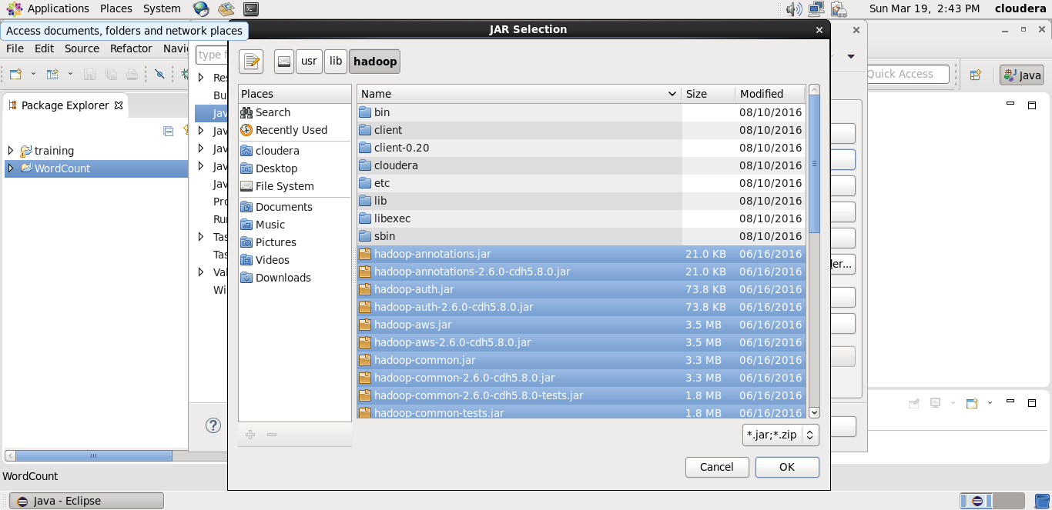

**Step 5:**

Again add all jar files in usr >> lib >> hadoop >> client directory and press OK.

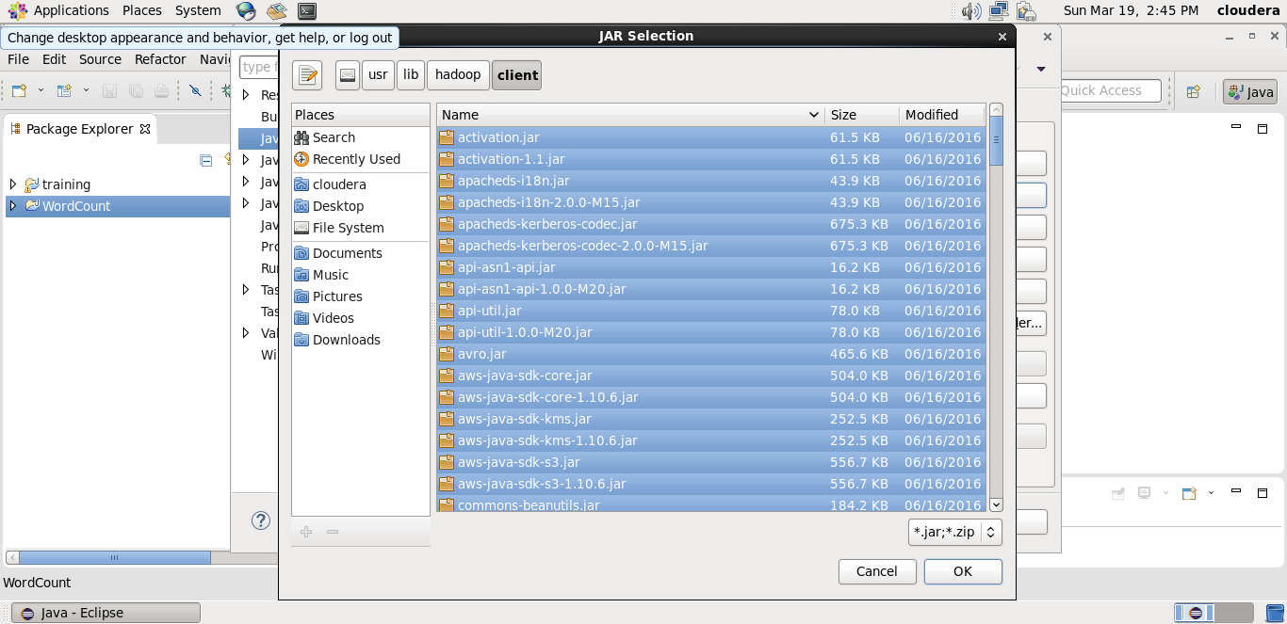

**Step 6:**

**Right click on src, New >>Class.**

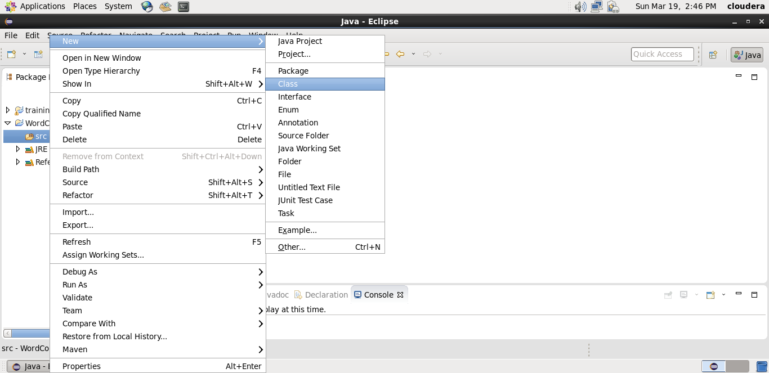

**Step 7:**

Enter the project name as ‘WordCount’ and click ‘Finish’.

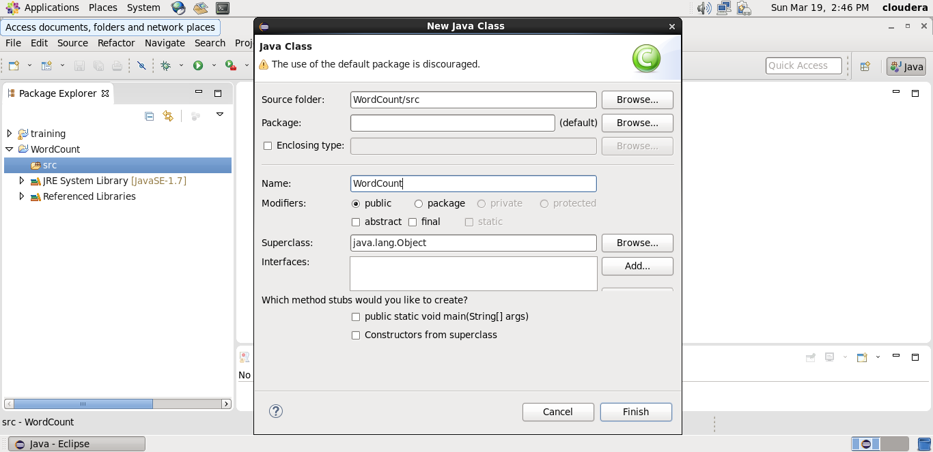

**Step 8:**

Open browser and copy and paste the Java Source code of map reduce program from the link given.

**Website link:** https://docs.google.com/document/d/1KlwHVv7JKq9bLph0GOLW5P7Kfj6fwQA6iHIMgIC6SOA/edit?usp=sharing

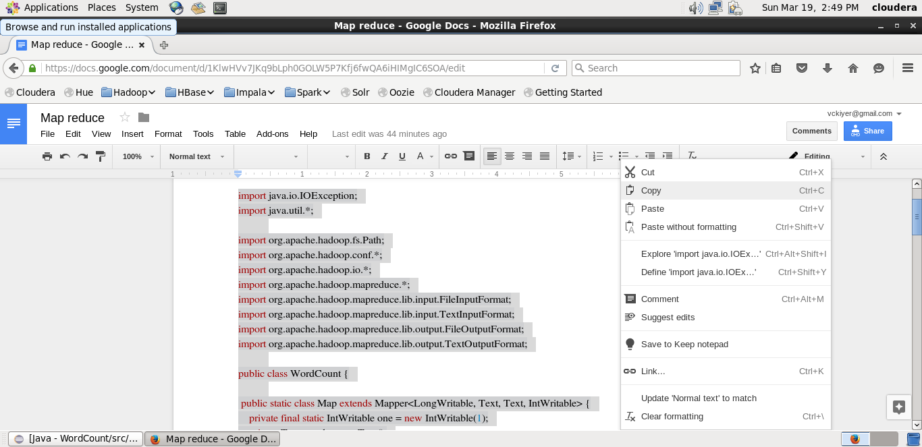

**Step 9:**

Right click on the WordCount project and select Export >> Java >> JAR file. Then click on ‘Next’.

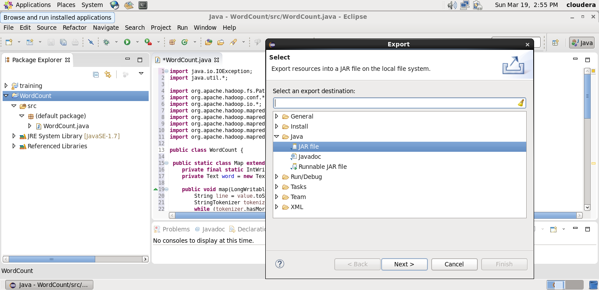

**Step 10:**

Name the JAR file and click ‘Finish’.

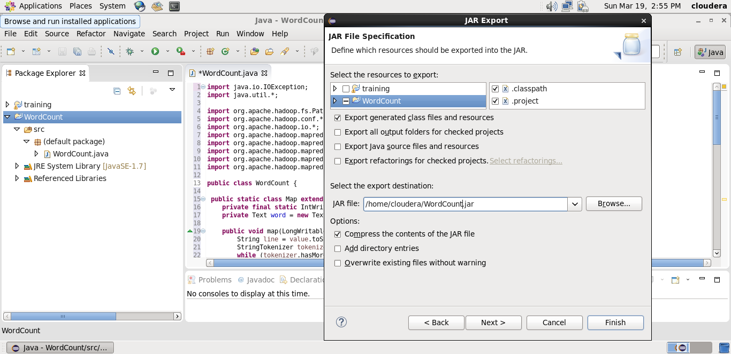

**Creating a text file for Mapreduce job to work on:**

**Step 11:** Open a new terminal and create a normal text file.

**Code: cat> /home/cloudera/wordcount.txt**

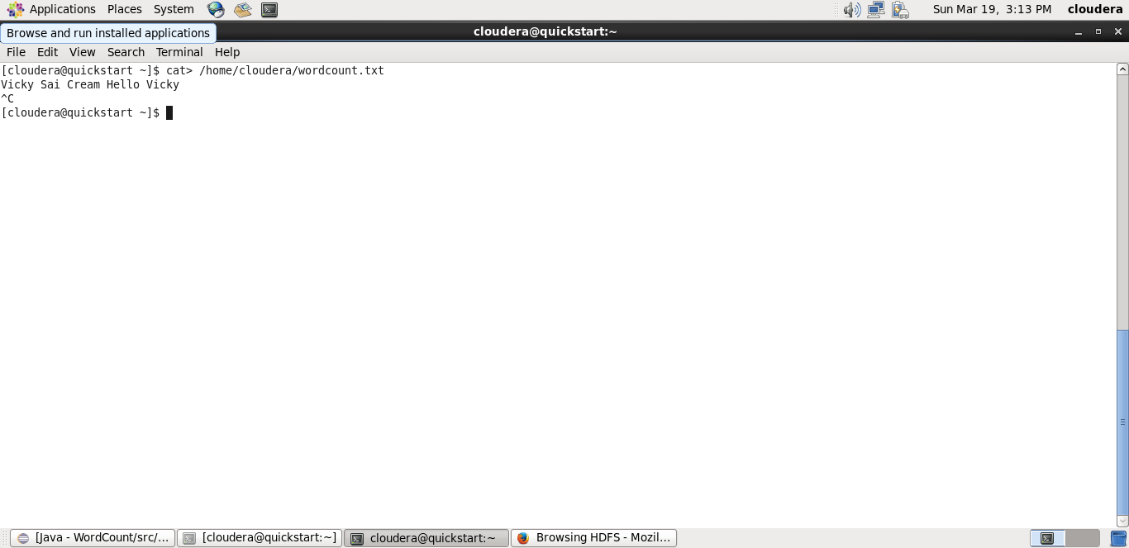

**Step 12:**

Make a new Directory using the following command.

**Code: hadoop fs -mkdir input**

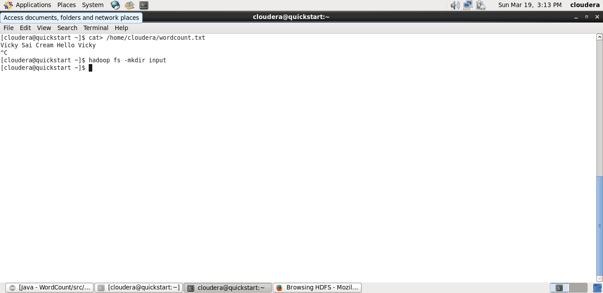

**Step 13:** Copy the created text file to the new directory created in HDFS.

**Code: hadoop fs -put /home/cloudera/wordcount.txt input/**

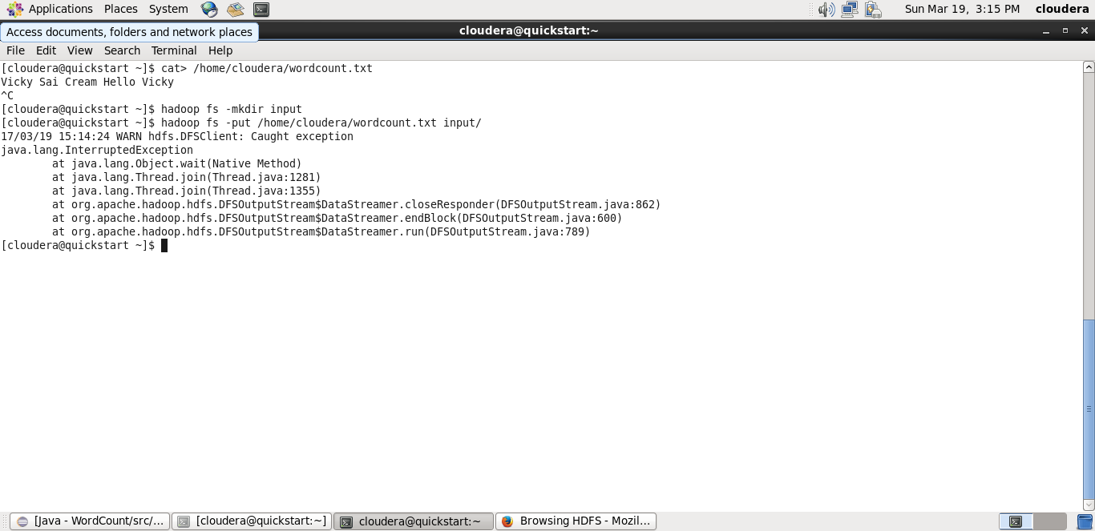

**Initializing mapreduce job:**

**Step 14:**

Initialize the mapreduce job by giving the following command and wait for sometime.

**Code:** hadoop jar /home/cloudera/WordCount.jar WordCount input/wordcount.txt output

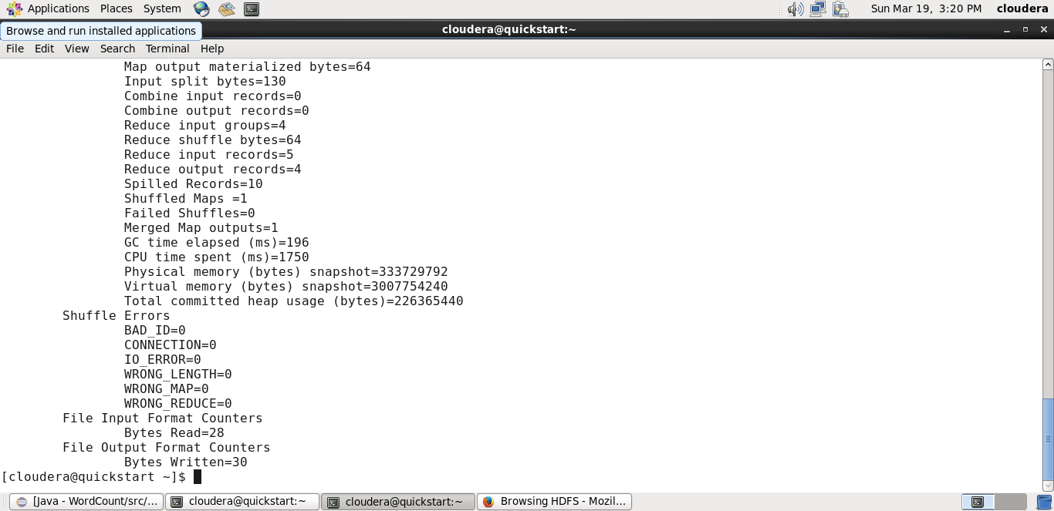

Now wait for about 50-70 seconds while the mapreduce job is being performed for the data created earlier.

**Output mapreduce job:**

**Step 15:**

The output directory of the mapreduce program is listed using the following command.

**Code:** hadoop fs -ls output

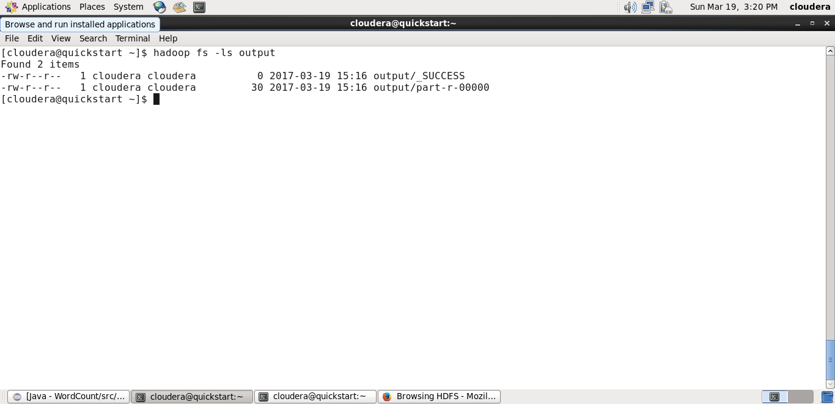

**Step 16:**

The final output of the mapreduce program is found using the following command.

**Code:** hadoop fs -cat output/part-r-00000

